‘Horizon Europe Info Day’
Online via Zoom
25th January 2022
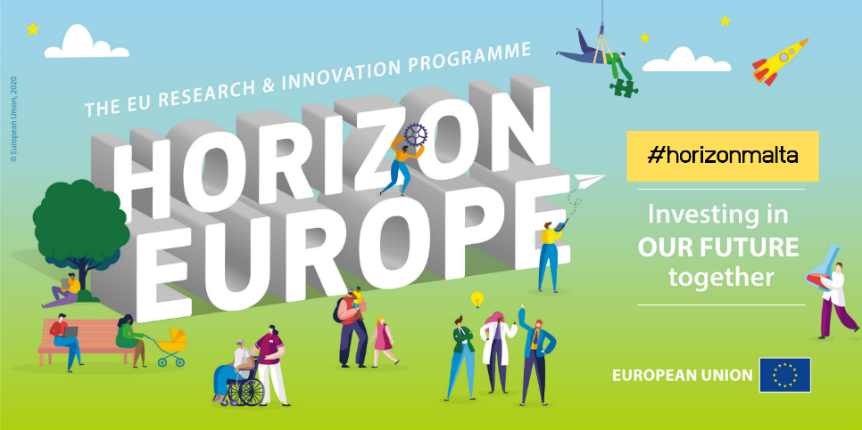
Agenda
09.00 – 09.15 | Joining Zoom
09.15 – 09.30 | Welcome and warm up exercise
09.30 - 10.10 | Introduction to Horizon Europe
10.10 – 10.50 | Opportunities for all scientific fields  - MSCA  - ERC  - Widening  - Research Infrastructures  - EIC
10.50 - 11.00 | Coffee break
11.00 – 11.15 | NCP services and support schemes
11.15 – 11.45 | Parallel sessions (Round 1)  - Health (cluster 1)  - Digital, Industry and Space (cluster 4)  - Climate, Energy, Mobility (cluster 5)  - Food, bioeconomy and environment (cluster 6)
11.50 – 12.20 | Parallel sessions (Round 2)  - Health (cluster 1)  - Culture (cluster 2)  - Security (cluster 3)  - Climate, Energy, Mobility (cluster 5)
12.20 - 13.00 | Lunch break
13.00 – 13.30 | Parallel sessions (Round 3)  - Health (cluster 1)  - Security (cluster 3)/ Digital, Industry and Space (cluster 4)  - Climate, Energy, Mobility (cluster 5)  - Food, Bioeconomy and Environment (cluster 6)

